# *Web Programming I (420-C10-HR)*

# *Lab 1 – Housekeeping & Introduction*

Date assigned: Tuesday, August 25, 2015

Date due: **Tuesday, August 25, 2015, at the end of lab**

**Learning Objectives**

Upon successful completion of this lab exercise, the student will have:

* Set up home drive, email and your Calendar
* Practice with Moodle quizzes, wikis and questionnaires
* Participate in the First Year Computer Science Survey

To do:

**Part A – Moodle**

1. Start a browser (Internet Explorer, Firefox, Chrome or Opera). The Heritage home page will be displayed. Click Moodle on the top line of the page. The Heritage Moodle home page will open:

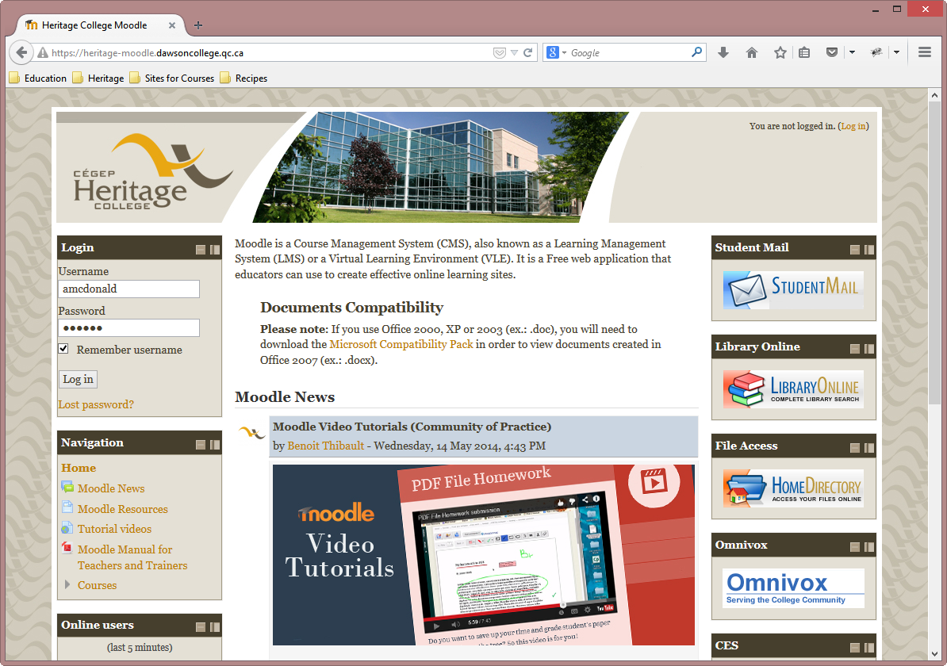

1. Type your username in the Username field under Login and type your network password in the Password field. Click the Login button.
2. Type **420-C10** in the **Search courses** box. The following page should display:

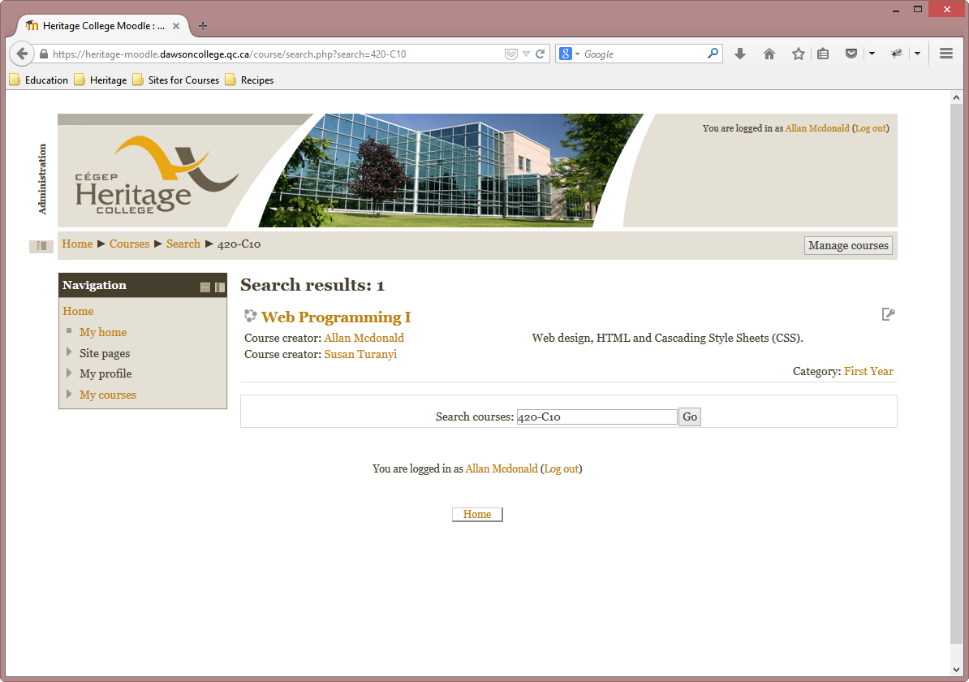

1. Click on Web Programming I.
2. Click the Enrol Me button. The enrollment key is **420C10**. The Web Programming I Moodle page will be displayed.

Assignment and lab files for this course will be available here. You will also submit your completed work here. At present the course outline and the files for lab 1 are available.

1. To complete the remainder of the lab, scroll to the Labs section and click on the file “Lab 01 – Housekeeping and Introduction” and open it. The remainder of the instructions for the lab are found in this file. Continue the lab at Part B, page 3 of the lab.

**Part B – Set Up Course Folders**

1. On to the network and select Documents from the Start menu or click the Documents icon on the taskbar. This will open your home drive documents folder (your H drive).
2. Click New Folder on the menu bar.
3. Replace the words New Folder with 420-C10.
4. Repeat steps 3 and 4 for 420-A13 and 420-B10.
5. Double-click on 420-C10. Create two new folders here – call one Labs and the other one Assignments.
6. Repeat step 5 for folders 420-A13 and 420-B10.

**Part C – Moodle Set-Up**

1. Save this file with the name **YourUserName_C10_L01_Introduction.docx** (e.g. jsmith_C10_ L01_Introduction.docx) in your H:\420-C10\Labs folder.
2. Record the answers to all the questions in green font in the document following the question.
3. Scroll through the Moodle course page. Besides the overview, there are general sections or topics. What are they?
4. labs
5. assignments
6. helpful links
7. resources
8. lectures, notes and slides
9. examples from class

**Part D - Microsoft® Outlook Set Up**

1. You will usually access your college email using webmail. There is another way to access your College e-mail using Microsoft Outlook. Start Microsoft Outlook 2010 by selecting **Start, Programs, All Programs, Microsoft Office 2013, Outlook 2013** The Outlook Startup window will open. Click Next.

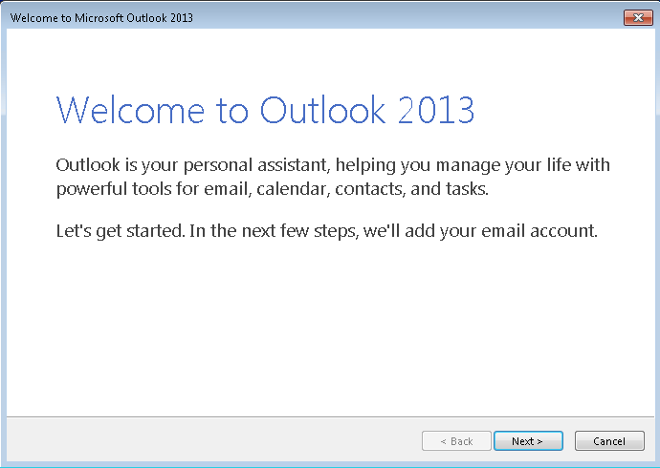

1. The next window asks you to confirm that you want to set up an account. Make sure the Yes option is highlighted and click Next.  
     
   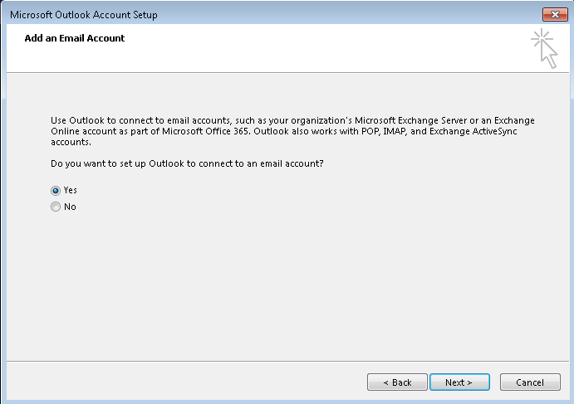
2. The Add New Email Account screen is displayed. Your name and email address should be filled in by default. If your name is not automatically filled in, add your email address in the Email address field. Your email address is your username with @cegep-heritage.qc.ca added to it.

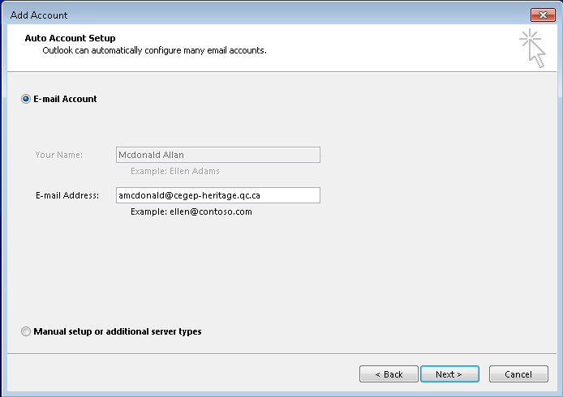

1. Click **Next**. Your email account should be successfully set up now:

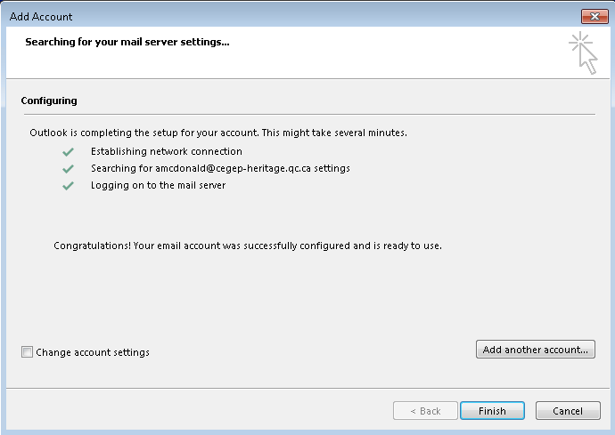

**If you do NOT receive the above screen, let me know immediately. Do NOT click finish. We may have to set up your account manually.**

1. Click **Finish**. Outlook 2013 will now open.

***Note***: You have set up your profile on the desktop computer. The next time you use this computer, simply open Outlook and your profile will be selected.   
  
If you use another computer, you will have to repeat this procedure to set up your profile there.

**Part E – First Year Student Survey**

1. Check your email for a message from the department coordinator, Susan Turanyi ([sturanyi@cegep-heritage.qc.ca](mailto:sturanyi@cegep-heritage.qc.ca)) with the Subject line: “Computer Science New Student Survey”
2. Select the message and read it. There is a link to a brief survey that we are conducting to get to know more about your expectations of the program so we can better support you in your college education. All questions on the survey are optional so you can choose not to answer them if you like. Click the link or copy and paste it to your browser. Complete the survey.
3. Remember all answers are optional, but we would like you to go through the survey from start to finish.
4. If you do not have the email, call me over right away and I will forward you another copy. You cannot forward the message to another student or to another email account.
5. Check your email again for an invitation from Susan to our first pizza lunch of the year. Accept it if you can make it and make sure you send Susan a response so she can keep track of who is coming or not.

**Part F - Calendar Set Up**

1. In Outlook, select **Calendar** from the bottom Task Bar and change the view to be **Week** or **Work Week** by selecting the tab above the dates (See Figure 1).
2. Set up your timetable by repeating the following steps for each course block in your timetable.
   1. Starting with Monday, August 24 (yesterday), select a block of time that corresponds to a course and then select **New Appointment** on the shortcut menu (See Figure 1).

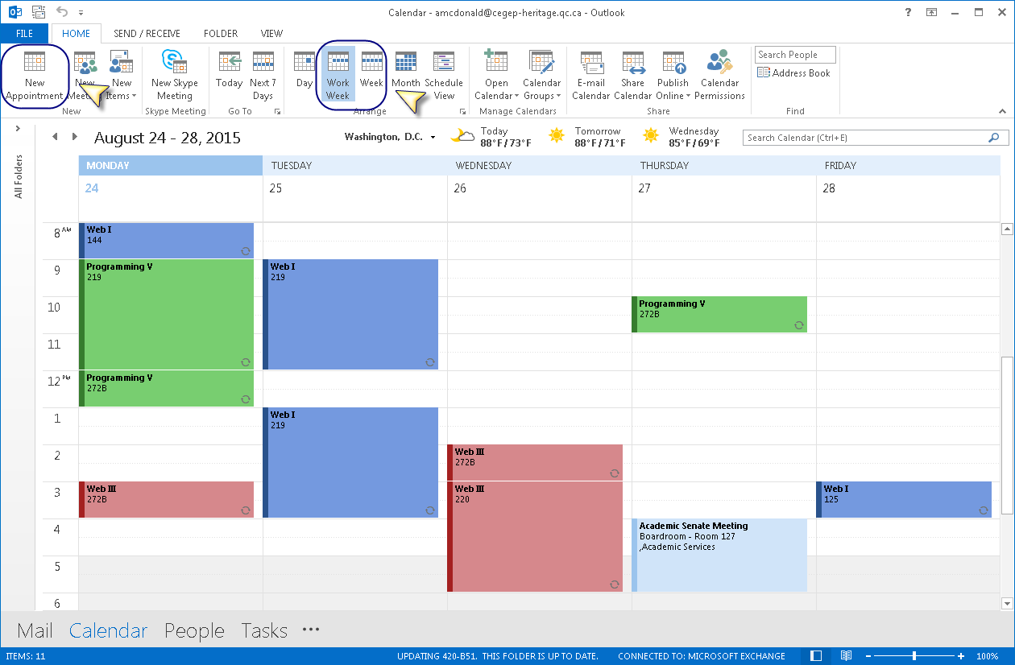

Figure 1: Calendar Page

* 1. Ensure that the Appointment is set up as follows:
     1. In the **Subject** box, type the name of the course. In the **Location** box, enter the room number.
     2. The Start and End time should be the starting hour and ending hour for the block in your timetable. The end time should **not** be changed to be 10 minutes before the hour. The Duration is automatically calculated.
     3. Set the Reminder for the entry to be None.
     4. Press the Recurrence button to set up repeats

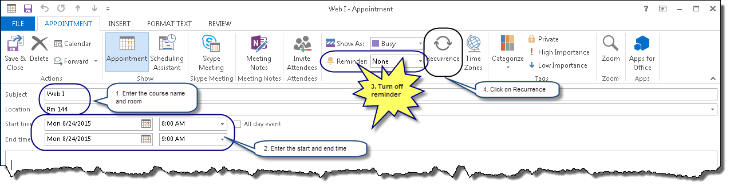

Figure 2: New Appointment

* 1. Set the recurrence to weekly with the appropriate day checked.
     1. Set the **Range of recurrence** to **End by:** December 9, 2015. Click **OK** (see Figure 3).

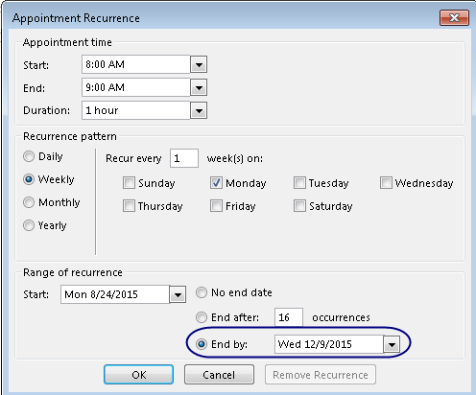

Figure 3: Recurrence Pattern

* 1. Colour-code your courses:
     1. Select the Categorize icon from the toolbox at the top.
     2. Find the Category matching the course and select the checkbox next to it to assign it to the current calendar entry.
     3. Create a different colour category for each course as in Figure 4.

If this is the first entry, you will have to set up the categories for your courses. To do this:

* + 1. Select the Categorize Dropdown.
    2. Select **All Categories…**
    3. Follow the steps to create your categories.

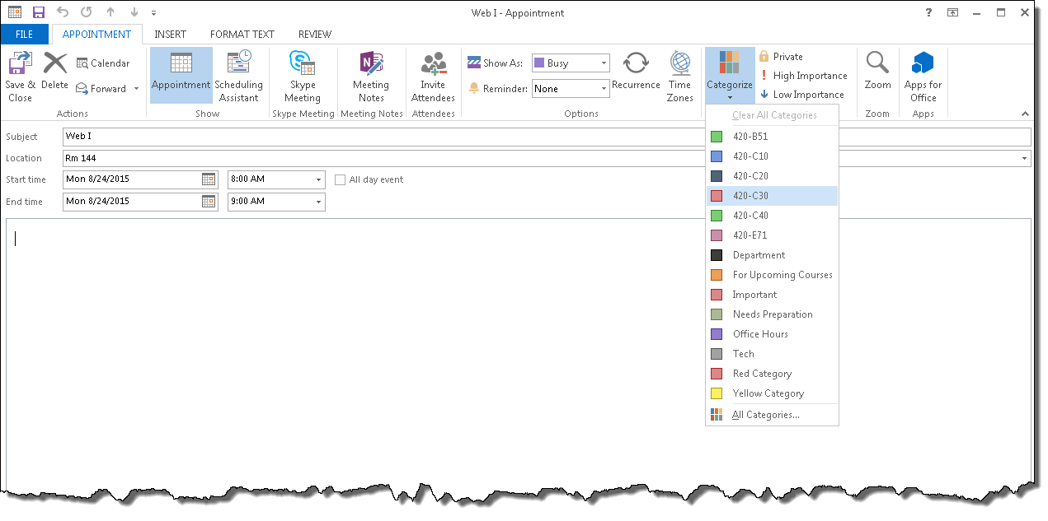

Figure 4: Colour Coding Courses

* 1. When the entry is complete, with recurrence set and colour coding complete, click **Save and Close**.

1. A copy of the Academic Calendar is linked to the lab in Moodle. Open the document now to complete the next section. Change your Outlook calendar to match the academic calendar as follows:
   1. Delete the occurrences on Labour Day (September 7) by selecting each block on that day and Deleting them either by clicking the X button in the menu bar or pressing the Delete button on your keyboard. Make sure that **Delete this occurrence** is selected when prompted.

### Delete the occurrences on the Wednesday after Thanksgiving (October 14) by selecting each block on that day and Deleting them either by clicking the X button in the menu bar or pressing the Delete button on your keyboard. Make sure that **Delete this occurrence** is selected when prompted.

### Move the occurrences from Thanksgiving (October 12) to the Wednesday after Thanksgiving (October 14) by double clicking each appointment and changing the date. Make sure that **This occurrence** is selected. You can also drag and drop the occurrence to the new day.

### Delete the occurrences on Tuesday November 3, by selecting each block on that day, selecting Delete from the shortcut menu, and ensuring that Delete this occurrence is selected.

### Move the occurrences from the midterm study day (November 6) to Tuesday, November 4 by double clicking each appointment and changing the date. Make sure that **This occurrence** is selected. You can also drag and drop the occurrence to the new day.

1. While viewing your calendar, make sure that the Home click on the Share Calendar button on the menu bar. See below.

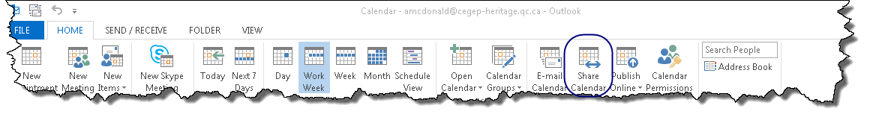

Figure 5: Sharing the Calendar

1. When prompted, specify that you share your calendar with the user **#Teaching Staff Computer Sciences** (all the Computer Science teachers). This will allow teachers to view your calendar. Make sure you specify Full Details in the Details drop down. See below.

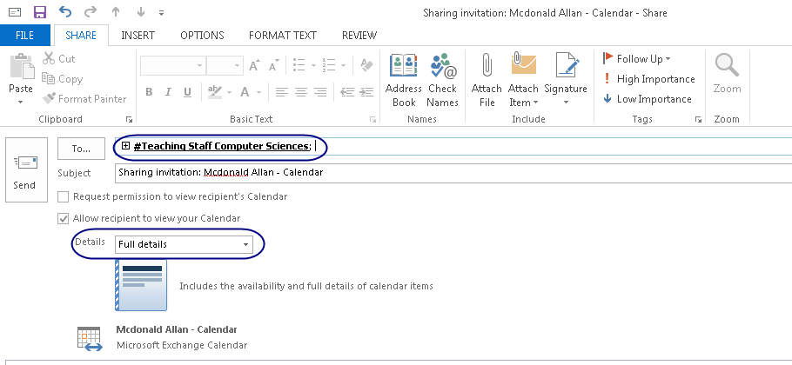

Figure 6: Sharing details

**Part G – Rules in Outlook**

Purpose: The purpose of this section of the lab is to set up a rule to direct all mail that is sent to all students to a subfolder so that your email inbox contains only mail directed to you specifically.

1. Start Web mail in Internet Explorer. (This only works in IE. The option isn't available in other browsers.)   
   (You can also do this in the desktop version of Outlook, but since you will likely be accessing your college mail through webmail most of the time, this will give you some practice using this version)
2. Click the gear in the upper right hand corner of the web page and choose Options.  
    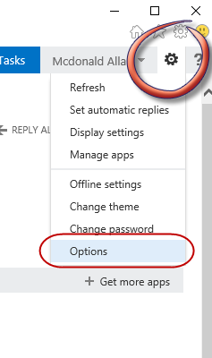
3. Select “organize email” from the navigation pane on the left. “inbox rules’ should be selected, if not select it.

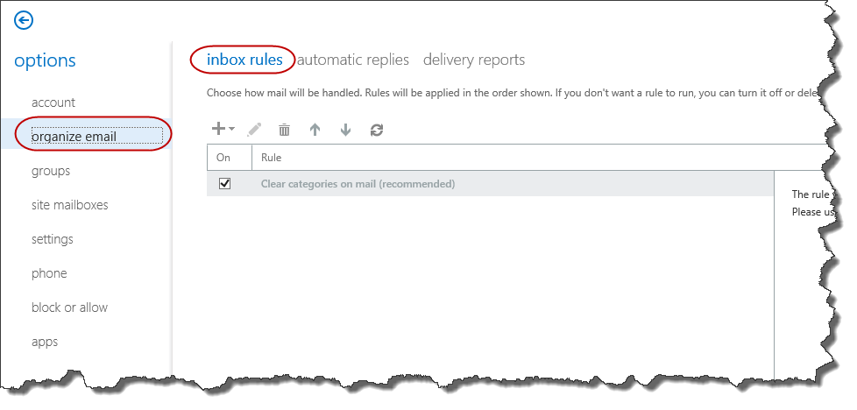

1. Select the Plus sign to add a rule. Select “Move messages sent to a group to a folder…” from the New Rule dropdown list.

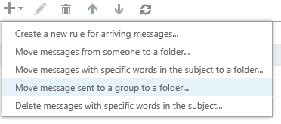

1. Give the rule the name “RemoveAllStudent” and use the Select people link to choose ##Heritage Students from the list.
2. Click the “Select one” link next to the Move the message to folder. When the Pop is displayed create a new folder and call it All Students.
3. When you click Okay the new rule form looks like this:

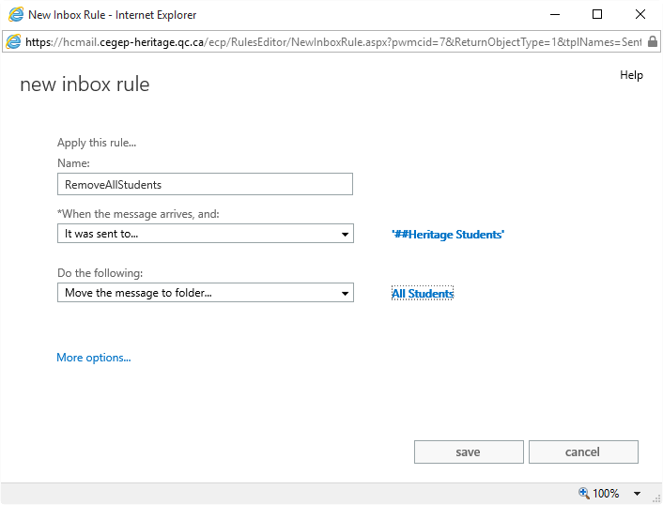

1. Click Save and then the Arrow to return to your Inbox. Any future messages sent to Heritage Students will now be moved to this folder. You can do other things such as delete these messages if you want.
2. Now you will only have messages that come to you of your class in your inbox. This will make it much easier to find your marked labs and assignments in your email.

**Part H – Using Moodle**

* 1. In Moodle, complete the questionnaire called **Lab 01 – Questionnaire**. Note, there are no right and wrong answers; the point is to get you used to using the questionnaire feature of Moodle.
  2. In Moodle, complete the quiz called **Lab 01 – Quick Quiz**. You can use whatever sources you want for the correct answers. Again, the answers are not really important (although you should try and get them right as this one will be marked); the point is to get you used to using this feature of Moodle.

**To submit**

When you have completed the lab exercise save this file in your labs folder on your H drive. Save a copy of the document as a PDF document (File -> Save as Adobe PDF) with the name **YourUserName_C10_L01_Internet_Intro.pdf**. Copy the PDF file to Moodle as per the Moodle instructions.